Assignment #3 Fact Checking

I’ve decided to investigate the popular prevention remedy of Cold FX. The following is a copy of the Cold FX web page, minus the picture of the bottle of pills.

# COLD-FX®

**Clinically proven to reduce the frequency, severity and duration of cold and flu symptoms.**

Each capsule of COLD-FX is certified to contain 200 mg of CVT-E002TM, a proprietary ChemBioPrint®  
(CBP®) product rich in poly-furanosyl-pyranosyl-saccharides extracted from the root of panax  
quinquefolius (North American ginseng, 4:1).

As a ChemBioPrint product, proprietary standardization technology has been used to identify and isolate  
the active ingredient (CVT-E002) and ensure consistency from batch to batch. The efficacy of CVT-E002  
is supported by clinical trials and is proven to provide health benefits by enhancing the immune system’s  
viral-fighting Natural Killer cells and macrophages.

**Non-medicinal ingredients:** Gelatin, natural capsule colour (chlorophyllin, titanium dioxide). Always read the label to ensure ingredients haven’t changed.

**Recommended purpose:**Helps reduce the frequency, severity and duration of cold and flu symptoms by boosting the immune system.

**Recommended use; Children 12 years of age or older:** Take 1 capsule 2 times daily. **Adults:** Take 1-2 capsules 2 times daily. COLD-FX may be taken for the duration of the Cold and Flu Season.

**Caution:** Individuals requiring anti-coagulant therapy such as warfarin should avoid the use of COLD-FX. Do not use if pregnant or breastfeeding. Not recommended for individuals with impaired liver or renal function. As COLD-FX is a derivative of North American ginseng, individuals with known allergies to ginseng should avoid use of COLD-FX. Do not exceed the recommended daily dose.

NPN 80002849

**Shelf-life:** 5 years at room temperature

(Valeant Canada Consumer Products, 2013)

As you can see the website quotes the ingredients and the fact that it is clinically proven to reduce frequency , severity and duration of cold and flu symptoms. I wanted to follow the claim “clinically proven” so I went ahead and tried to find the actual clinical results.

The site uses “brand ambassadors” such as popular Canadians Alex Biliodou and Don Cherry. A typical quote from these brand ambassadors was similar to the Don Cherry Quote below:

“A chance meeting at the game between CBC's Ron McLean and a senior official of COLD-FX maker, Afexa Life Sciences Inc was destined to lead to Don Cherry becoming the Company's celebrity spokesman! When the topic of COLD-FX came up in conversation, Ron said, "You should get a hold of Grapes, he loves the product." We did. Don met Dr. Jackie Shan who discovered COLD-FX and told her he decided to try it out when he discovered Glenn Sather and the Edmonton Oilers were using it. He said, "If it's good enough for them, it's good enough for me." He was also impressed by the fact that the breakthrough product came from a 'struggling, true blue Canadian Company." This detail was not lost on a man who always backed the underdog. In exchange for Don's support, Afexa offered to provide funding to his favourite charity – a palliative care home for kids named in honour of his deceased wife, Rose. In no time, supported by rock solid science and one of Canada's most famous and trusted personalities, COLD-FX sales skyrocketed to become # 1 in Canada. Oh yeah, Don now says he 'pretty much never gets the colds anymore' which used to plague him from childhood.”

This was the closest to any kind of actual real life testimony. Some of the ambassadors didn’t even have a quote. At no time was any scientific clinical data ever stated in the Brand ambassdor link.

When I clicked on the Health Care Professional link, all that came up were precautions as to who shouldn’t use the product and the claim below. When I clicked on the link “For more information on Safety and Side Effects **[Click Here](http://coldfx.ca/health_safety.htm" \t "_blank)**” the website wouldn’t load. All I received was an infinite “Oops” page

# The testimonial link again was full of quotes from popular sources like Dr. Oz etc. Nearing the bottom of the testimonies, I found the co-authors of a journal article on Cold FX that was published in the Canadian Medical Association Journal. I searched those authors and found the article. The tables are listed below:

[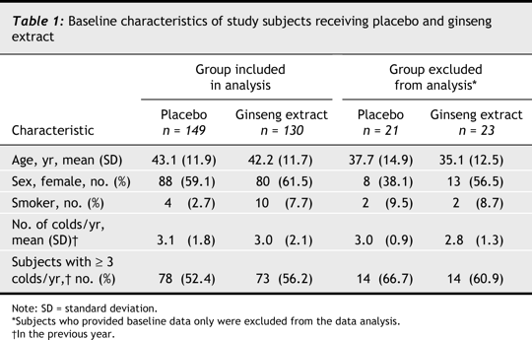](http://www.cmaj.ca/content/173/9/1043/T1.large.jpg)

[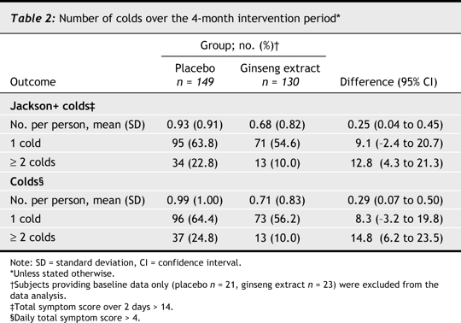](http://www.cmaj.ca/content/173/9/1043/T2.large.jpg)

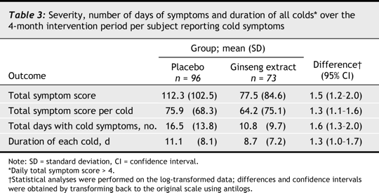

[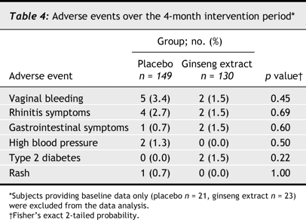](http://www.cmaj.ca/content/173/9/1043/T4.large.jpg)

(Predy, Goel, Lovlin, Donner, Stitt & Basu, 2005)

Limitations of the study:

First of all the study only looked at 130 people. On page 198 in your textbook you state the participant taking the test should represent the larger group you are hoping to generalize. I am sceptical if a test on 130 people is enough to be generalized for a preventative measure for the common cold and flu for the nation of Canada..

The first 3 tables use the confidence interval. I have learned that the confidence interval is similar to the probability value; however it is usually stated in percentage. The values are listed in decimal form. The confidence interval is confusing because while the number per person value .04-.045 the values jump to -2.4 to 20.7 in table two. The values stated then are outside the 95% confidence value. Table three follows much the same pattern. Table 4 was the only table that states a p value is the adverse event study. I interpret this to mean that if you take Cold FX the probability of suffering from an adverse event is statistically insignificant.

If you can use the confidence interval values as probability values, then only the number per person value is a statistically significant value for the Jackson+ cold. No other values in the chart would be statistically significant.

The study found it’s participants through a media advertisement, which is not a random sampling. Authors of the study interviewed and chose suitable participants. (People who hadn’t been vaccinated, or had immunity issues) The participants were randomly assigned to take either the ginseng extract or a placebo.

My final criticism of the study was that it was all done in Edmonton, the city where the company is located, and was funded by the company itself.

References

Valeant Canada Consumer Products. (2013). *Cold-fx*. Retrieved from <http://cold-fx.ca/>

Predy, G., Goel, V., Lovlin, R., Donner, A., Stitt, L., & Basu, T. (2005). Efficacy of an extract of north american ginseng containing poly-furanosyl-pyranosyl-saccharides for preventing upper respiratory tract infections: a randomized controlled trial. *Canadian Medical Association Journal*,*173*(9), doi: 10.1503/cmaj.1041470